**Week 05-02:**

**Name:Snehan.s**

**Roll no:24801272**

**1.** The k-digit number N is an Armstrong number if and only if the k-th power of each digit sums to N. Given a positive integer N, return true if and only if it is an Armstrong number.

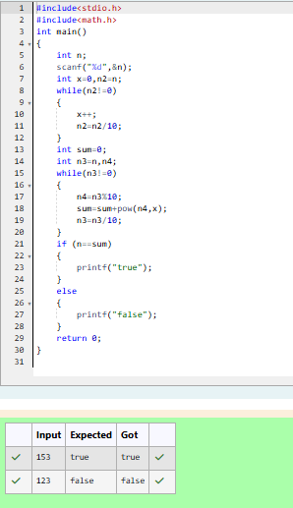

2. Take a number, reverse it and add it to the original number until the obtained number is a palindrome.

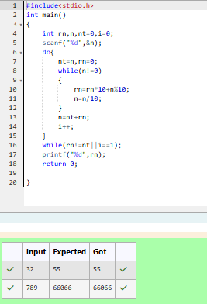

3. A number is considered lucky if it contains either 3 or 4 or 3 and 4 both in it. Write a program to print the nth lucky number. Example, 1st lucky number is 3, and 2nd lucky number is 4 and 3rd lucky number is 33 and 4th lucky number is 34 and so on. Note that 13, 40 etc., are not lucky as they have other numbers in it.

